Overview  Country or Region: Global (300 clients in 40 countries)  Industry: Financial services, information technology  Customer Profile  Thomson Financial is a U.S.$1.9 billion provider of information and technology solutions to the worldwide financial community.  Business Situation  Thomson wanted to evolve the company’s core portfolio accounting platform to support optimized workflow.  Solution  Thomson programmers, working with the Microsoft® .NET Framework 3.0 application programming interface components, are developing the company’s next generation of portfolio accounting platform.  Benefits  - Big functionality, little effort  - Efficient development cycle  - Stunning, flexible software |  |  | “Our clients place enormous value in being able to customize PORTIA, and the .NET Framework 3.0 lets users configure PORTIA to meet their unique workflow needs.”  Christy Bremner, President, Thomson PORTIA
 |  |  | Over the past 20 years, asset managers at hundreds of firms have relied on Thomson Financial PORTIA® to securely and reliably account for and manage portfolios. Although PORTIA’s functionality is second-to-none, Thomson felt that customers and prospects needed a more modern approach to workflow. In two days, Thomson worked closely with architects at the Microsoft Technology Center in Waltham, MA, to design the future of PORTIA workflow, called PORTIA Workspace. In just six months, designers and programmers created the Workspace by using the Microsoft® .NET Framework 3.0 application programming interface and cutting-edge Microsoft design and development software. The highly customizable PORTIA Workspace is poised to take advantage of advances in the Windows Vista™ operating system, extend the value of a trusted Thomson brand, and help asset managers achieve unprecedented efficiency.
 |  |  | 

Situation
Thomson Financial is a US$1.9 billion provider of information and technology solutions to the worldwide financial community. With the widest range of products and services in the industry, Thomson Financial helps clients make better decisions and achieve superior results. Thomson Financial is part of The Thomson Corporation (www.thomson.com), a global leader in providing integrated information solutions to business and professional customers. Thomson provides value-added information, software tools, and applications to more than 20 million users in the fields of law, tax, accounting, financial services, higher education, reference information, corporate e-learning and assessment, scientific research, and health care. With revenues of U.S.$8.5 billion, The Thomson Corporation lists its common shares on the New York and Toronto stock exchanges (NYSE: TOC; TSX: TOC).

Thomson PORTIA® is the company’s powerful and comprehensive portfolio management system that automates the trading, analysis, and operations of more than 300 asset managers in 40 countries, managing more than U.S.$10 trillion in assets.

PORTIA enables insurance companies, bank trusts, plan sponsors, asset managers, and corporate treasury departments to securely and reliably manage investment portfolios. Users interacted with PORTIA via a menu system, so performing daily activities typically required many time-consuming steps. In addition, the software provided minimal opportunity for users to customize the interface to suit their liking and automate their day-to-day work tasks. Thomson needed a more flexible and modern approach to workflow.
Fast Facts
Number of developers | 7
Estimated months to complete | 6
Developer and designer tools | - Microsoft Visual Studio 2005 Team System  - Visual Studio visual designer for Windows Presentation Foundation  - Microsoft Expression Interactive Designer
Programming languages | Microsoft Visual C#
Programming model and technologies | - Microsoft .NET Framework 3.0  - Windows Presentation Foundation  - Windows Workflow Foundation  - Windows Communication Foundation

“With any system, if you have to do ten actions just to complete a task, that’s a rather painful workflow,” says Christy Bremner, President, Thomson PORTIA. “We wanted to eliminate as many steps as possible, allow our customers to define their own workflows, and automate their desktops for optimal efficiency.”

Solution
Thomson Financial turned first to Microsoft® technology and experts to design and develop the company’s next-generation portfolio accounting system. As shown in Figures 1 and 2, the PORTIA Workspace has a high presentation-quality user interface and provides users with the flexibility to define custom workflows and then access the details of a workflow with a single click. They can also create their own menus and icons to personalize the way that they interact with the PORTIA Workspace.

Conceiving a Portfolio Accounting Solution
Thomson consulted the Microsoft Technology Center in Waltham, Massachusetts, for advice on the PORTIA Workspace architecture and to learn more about the latest generation of Microsoft .NET connection technologies.

“The Microsoft team showed that they understood our business needs and demonstrated how the Microsoft .NET Framework 3.0 meets those needs,” remarks Bremner. “They helped us envision the possibilities and develop a working architecture.”

Developing PORTIA Workspace
Thomson has been developing the PORTIA Workspace by taking advantage of the visualization, integration, and communication enhancements afforded by the Windows Vista™ operating system. Seven developers and one designer are creating the PORTIA Workspace. Thomson has an aggressive schedule and expects to launch the PORTIA Workspace at the beginning of 2007. At that time, the Thomson software team will have spent only about six months developing PORTIA Workspace.

Programmers are relying on the Microsoft .NET Framework 3.0 application programming interface, which provides the managed code programming model for the Windows® operating system. It combines the power of the Microsoft .NET Framework 2.0 with new technologies for building applications that have visually compelling user experiences, seamless communication across technological boundaries, and the ability to support a wide range of business processes. To build PORTIA Workspace, Thomson is relying on the following .NET Framework 3.0 components:
- Windows Presentation Foundation
- Windows Workflow Foundation
- Windows Communication Foundation
Graphical Elements: Windows Presentation Foundation
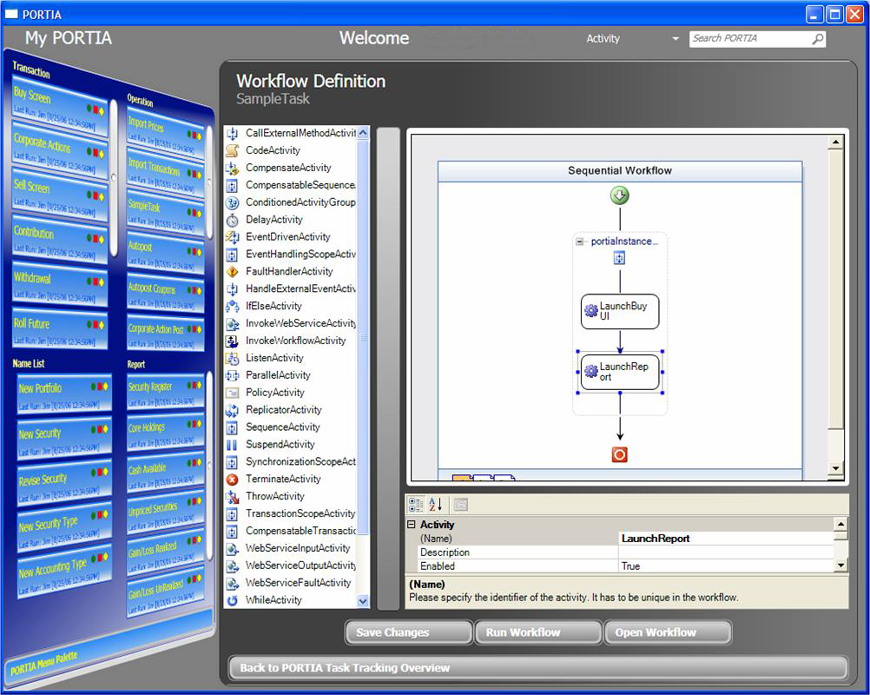
Figure 1. Thomson is hosting Windows Workflow Foundation in PORTIA Workspace. With this visual interface, users can chain together several activities and automate them.
The Thomson software team took advantage of Microsoft Expression® Interactive Designer, as well as Microsoft Visual Studio® visual designer for Windows Presentation Foundation, part of the Visual Studio 2005 Team Edition development environment.

Because Expression Interactive Designer and Visual Studio share the same project files, Thomson designers and developers can pass Extensible Application Markup Language (XAML) and code written using the Microsoft Visual C#® development tool between the applications. In turn, developers can build, deploy, and add functionality to the application without disturbing design elements. The shared XAML code allows designers to carefully tailor the look, feel, and behavior of the interface with assurance that their designs will be implemented as intended.
Dominic Flanagan, Vice President of Technology for PORTIA, elaborates, “We’re using iterative development cycles—very aggressive cycles, at that—so the ability to seamlessly move from design into development helps keep us on schedule by dramatically shortening the development cycle.”

Thomson developers rely on Windows Presentation Foundation to create the PORTIA Workspace navigation, usability, and look-and-feel elements.

Bremner comments, “Windows Presentation Foundation helps us accomplish the usability and interface elements we need, and that users appreciate. The quality of animations and screen transitions, for example, makes the interface very compelling and usable.”

Thomson is creating the PORTIA Workspace to run on Windows XP and Windows Vista. The Microsoft .NET Framework 3.0 supports either client operating system. By using the .NET Framework 3.0 and Windows Presentation Foundation, Thomson programmers can easily enhance the PORTIA Workspace user experience to include user-control elements, such as a three-dimensional carousel, found in the Windows Aero™ user experience.
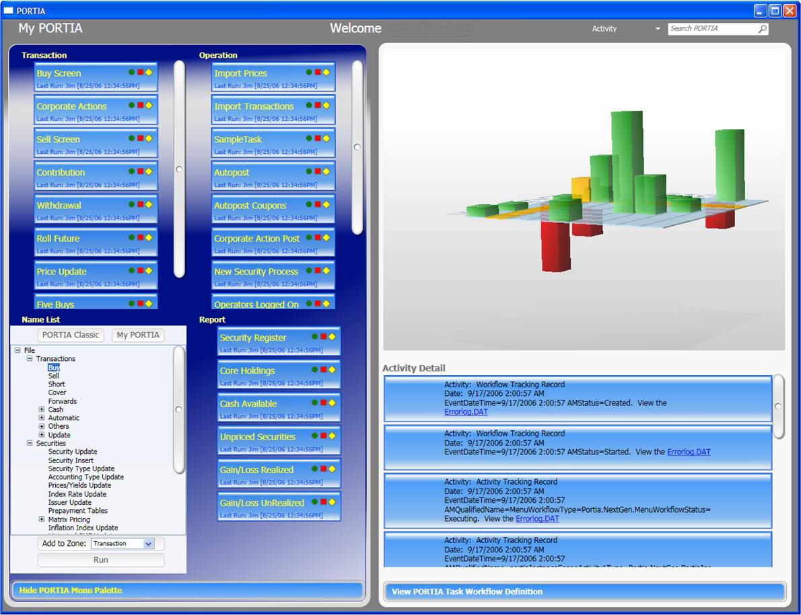
Figure 2. Screen capture of PORTIA Workspace.

Communication and Workflow Elements: Windows Communication Foundation and Windows Workflow Foundation
At a given customer site, the PORTIA Workspace might need to communicate with any number of business applications. Programmers relied on Windows Communication Foundation to quickly and easily build the integration elements they needed.

Windows Communication Foundation offers a unified programming model and runtime for building service-oriented applications. It is the .NET Framework 3.0 technology for rapidly building connected systems.
“Expression Interactive Designer and its Visual Studio counterpart increase collaboration between design and development so the process is more efficient and, therefore, faster and less expensive.”
Dominic Flanagan, Vice President of Technology, Thomson PORTIA

Flanagan says, “To get a very powerful service-oriented architecture layer, we can take slices of functionality, wrap them and expose them as specific services within Windows Communication Foundation, and make those specific services—those small ‘touch points’—available as activities within [Windows] Workflow Foundation. Using Windows Communication Foundation and Windows Workflow Foundation together is very powerful.”

To give users the ability to customize the PORTIA Workspace, developers needed a way to model and support business processes. In Windows Workflow Foundation, they had at their disposal a programming model, engine, and requisite tools. Windows Workflow Foundation is key to the flexibility of the PORTIA Workspace.

Thomson developers hosted the Windows Workflow Foundation workflow designer in the PORTIA Workspace, as shown in Figure 1. Portal managers, system administrators, and operations staff can create the functionality they need by using the workflow designer.

Bremner says, “What’s nice is that a company can have several types of users, each with specific tasks or responsibilities. We’re delivering the technology and letting customers decide how they want to deploy it.”

System administrators, for example, can set up and deploy a desktop for a specific role
(set of users) within an organization. That desktop might have only the functionality those users need. But administrators can also deploy the PORTIA Workspace in a very open-ended way, in which an end user has the complete set of all capabilities and functions.

Benefits
Already a trusted, secure, reliable transaction processing and accounting system that hundreds of asset managers use, PORTIA is poised to become an even more valuable tool for Thomson and customers worldwide.

Thomson Financial recently revealed a prerelease version of the PORTIA Workspace at a conference and received overwhelmingly enthusiastic reviews. “Our customers were incredibly excited about the possibilities of PORTIA Workspace,” Bremner says. “They recognize how it can have a dramatic effect on improving efficiency, optimizing workflow across the organization, and simplifying day-to-day activities for every user. Our clients place enormous value in being able to customize PORTIA, and the .NET Framework 3.0 lets users configure PORTIA to meet their unique workflow needs,” says Bremner.
“The ability to use the Windows Workflow Foundation workflow designer model and host that model directly in our application avoided huge amounts of development work.”
Dominic Flanagan, Vice President of Technology, Thomson PORTIA

For Dominic Flanagan and the Thomson software team, using the Microsoft .NET Framework 3.0 and cutting-edge Microsoft programming and design tools has many benefits. These benefits include unprecedented functionality and speed-to-benefit through an accelerated development cycle.

Big Functionality, Little Effort
Thomson experiences big benefits from using cutting-edge Microsoft software and technologies. “Without the capabilities of the .NET Framework 3.0, creating something like PORTIA Workspace wouldn’t have been cost-justifiable,” says Flanagan. “It would have been too risky to even consider.”

The Microsoft .NET Framework 3.0 provided much of what Thomson needed to make PORTIA Workspace a reality and helped the software team cost-effectively meet the tight development milestones. “The ability to use the Windows Workflow Foundation workflow designer model and host that model directly in our application avoided huge amounts of development work,” says Flanagan.

The Thomson software team found that having a single development environment and programming model was immensely useful.

Flanagan says, “Having one development environment that crosses all three .NET Framework technology components and every layer of our application—front end, middle-tier workflow model, and communication layer—within one environment is very powerful and helps our software team be even more efficient.”

Efficient Development Cycle for Stunning, Flexible Software
Previously, a designer would use graphics software to build pictures or storyboards. The designer would then hand these off to a developer who would implement the design by writing code. In contrast, with Expression Interactive Designer and Visual Studio visual designer for Windows Presentation Foundation, Thomson smoothly moved from design into development with less effort.

The .NET Framework 3.0 and Windows Presentation Foundation provide useful programming support for creating compelling user experiences. In addition, XAML provides a common basis for designer-developer collaboration by allowing both roles to work from the same project files.

“Expression Interactive Designer and its Visual Studio counterpart increase collaboration between design and development so the process is more efficient and, therefore, faster and less expensive,” says Flanagan.

Working with the .NET Framework 3.0, the team accomplished the highly customized user interface they wanted, achieving stunning animation and transitions. “The Microsoft .NET Framework 3.0 helped us create the best customer experience possible,” says Bremner.
Windows Vista
For More Information
For more information about Microsoft products and services, call the Microsoft Sales Information Center at (800) 426-9400. In Canada, call the Microsoft Canada Information Centre at (877) 568-2495. Customers who are deaf or hard-of-hearing can reach Microsoft text telephone (TTY/TDD) services at (800) 892-5234 in the United States or (905) 568-9641 in Canada. Outside the 50 United States and Canada, please contact your local Microsoft subsidiary. To access information using the World Wide Web, go to: www.microsoft.com

For more information about Thomson products and services, call (800) 354 9706 or visit the Web site at: www.thomson.com

© 2006 Microsoft Corporation. This case study is for informational purposes only. MICROSOFT MAKES NO WARRANTIES, EXPRESS OR IMPLIED, IN THIS SUMMARY.

Document published November 2006

Software and Services  - Windows Vista  - Microsoft Expression Interactive Designer  - Microsoft Servers  - Microsoft Windows Server 2003  - Microsoft Visual Studio  - Microsoft Visual C#  - Microsoft Visual Studio 2005 Team System | - Technologies  - Microsoft .NET Framework 3.0  - Windows Communication Foundation  - Windows Presentation Foundation  - Windows Workflow Foundation

Windows Vista can help your organization use information technology to gain a competitive advantage in today’s new world of work. Your people will be able to find and use information more effectively. You will be able to support your mobile work force with better access to shared data and collaboration tools. And your IT staff will have better tools and technologies to enhance corporate IT security, data protection, and more efficient deployment and management.

For more information about Windows Vista, go to:
www.microsoft.com/windowsvista

